

Week 03 – Task: Assignment – A romantic story

STUDENTS:
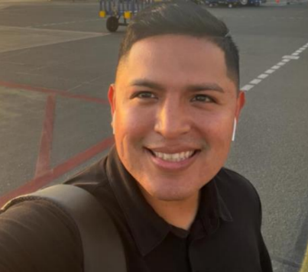

BENITES CORAZON, MAX ANDERSON
GAVINO COLLANTES, MARIA ALEXANDRA
CARHUAS BERNAL, GRESSI ELIZABETH

Subject: A Romantic Night at the Movies
Hi my friend,
Yesterday, María, Gressi and I went to the cinema and watched “50 First Dates”, the most romantic movie we have ever seen. The story happened in Hawaii. Henry met Lucy in a café and fell in love immediately, but she had short-term memory loss. Henry tried to win her heart every single day. They were having breakfast when she forgot him again, however, he never gave up. We laughed a lot because it was also a comedy, but María and Gressi cried when Lucy broke up with Henry. We really loved the movie; in addition, the soundtrack was beautiful. On the other hand, the ending was surprising and emotional. In conclusion, we enjoyed the night a lot.

With love,
Your friends,
María, Gressi and Max

